PRACTICAL 4

STEP 1

ADD A 3D PLANE USING GAME OBJECT

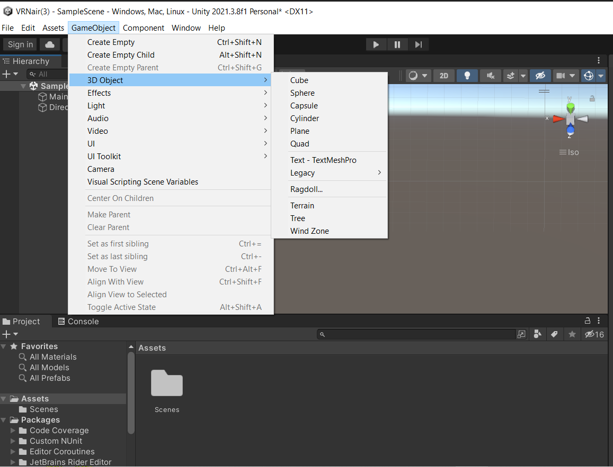

Add a sphere using Game Object

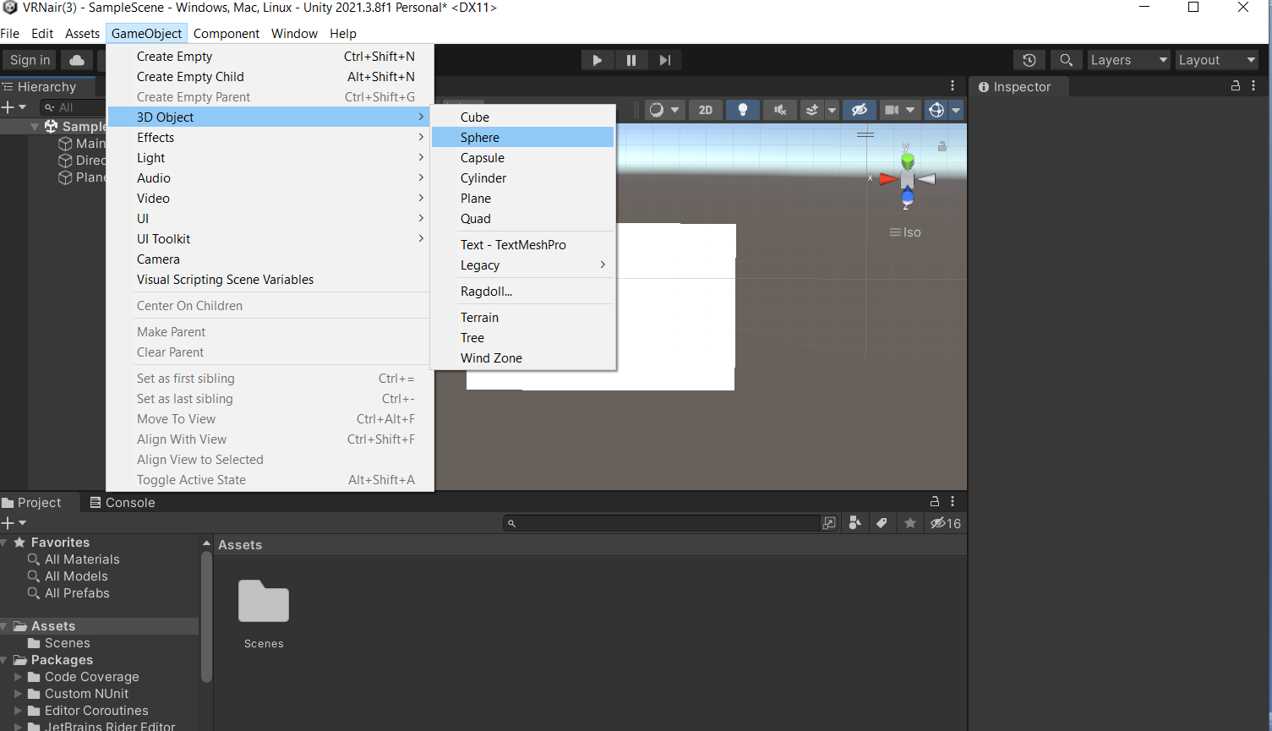

Change sphere Y axis position to “ 2 “ , X =0 , Z = 0

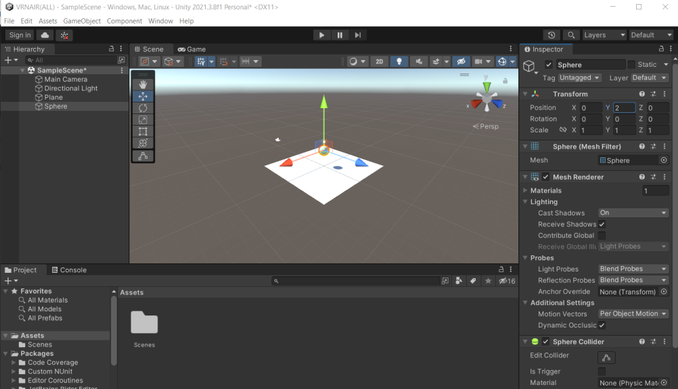

Select Directional light and disable it

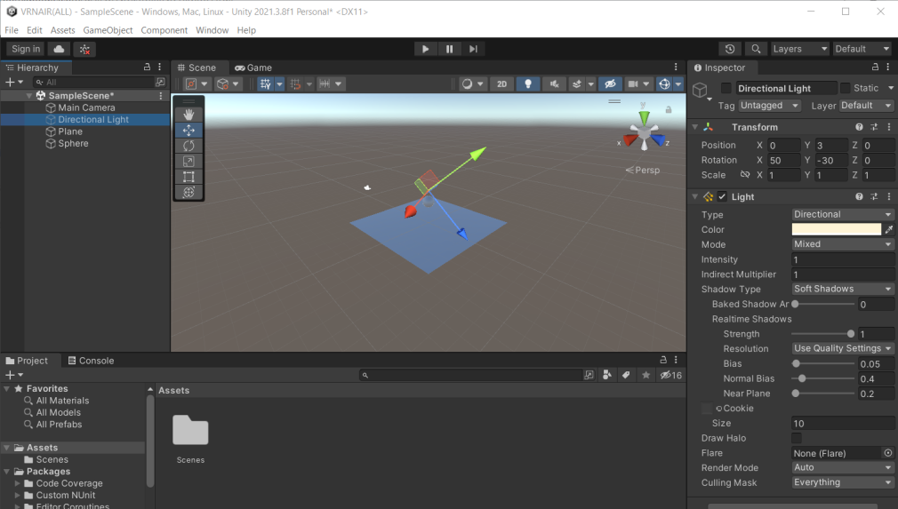

Add a Point Light using Game Object>light

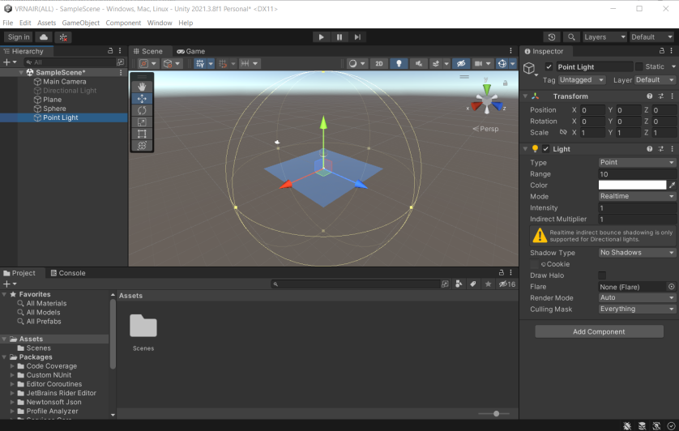

Change point lights position to X =1.5 Y=3 Z=0

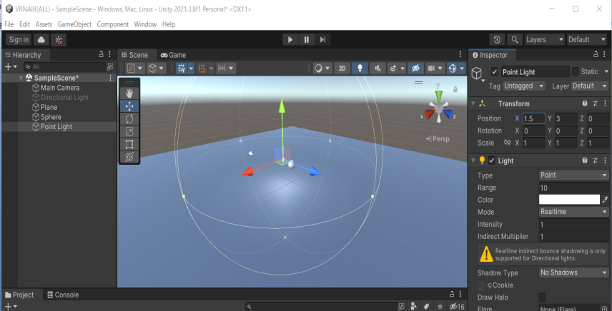

Change point plane’s Scale to X =5 Y=5 Z=5

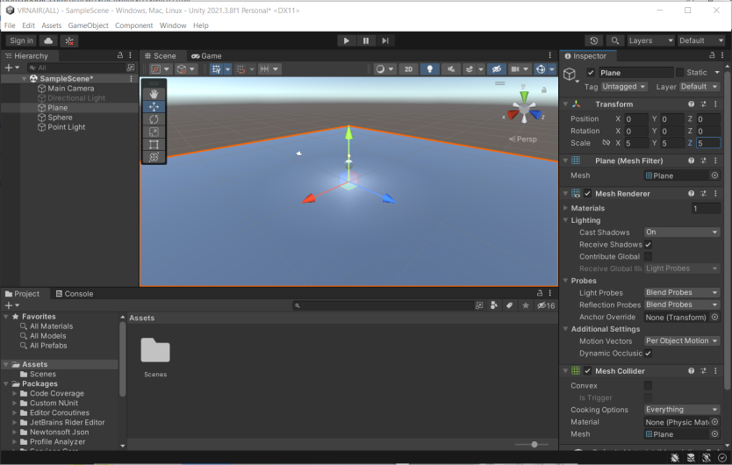

Create a duplicate point light by right clicking on it

Change point light (1) position to X =-1.5 Y=3 Z=0 (MINUS 1.5)

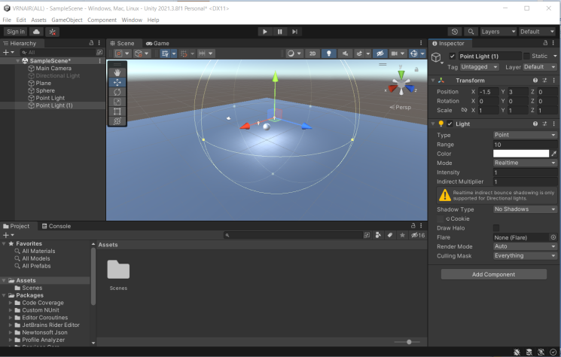

Change the color of light as you like

Go to project window right click > create > c# script

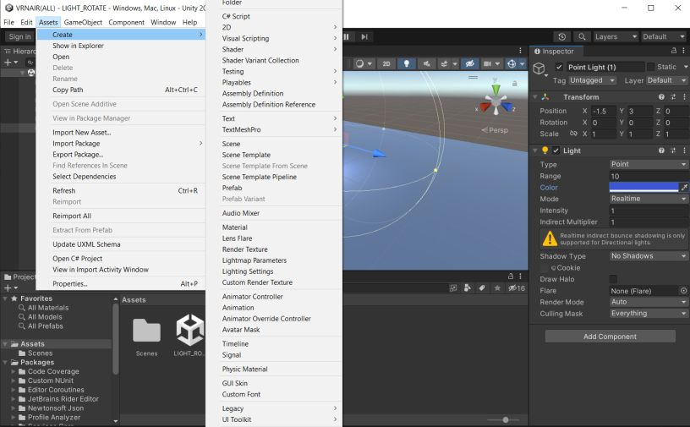

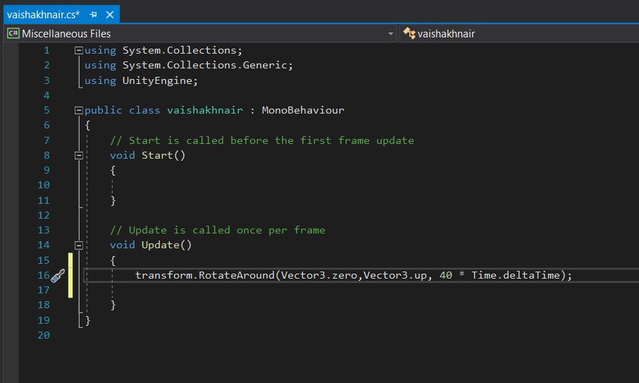

ADD NEWLY CREATED SCRIPT TO POINTLIGHT

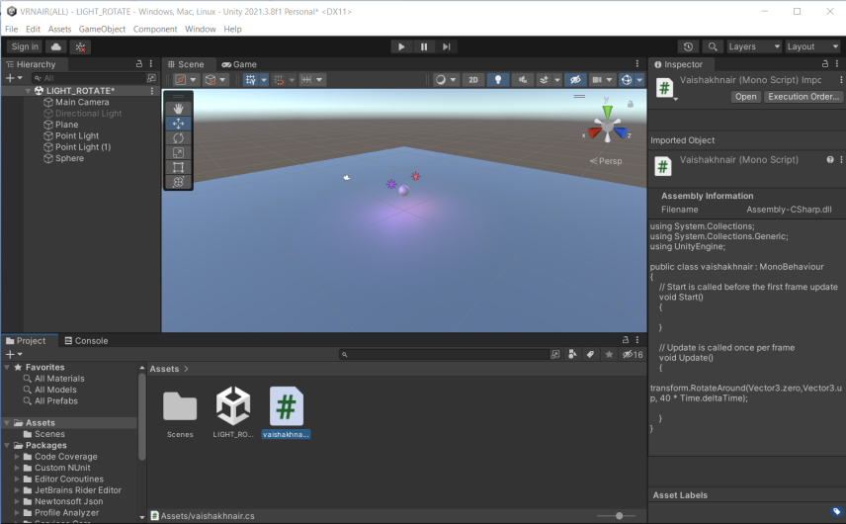RUN THE APPLICATION : OUTPUT:

